FINAL EXAMINATION
TIME ALLOWED: 90’
Subject: Linear Algebra.
No books allowed.
- Compute, using de Moivre’s formula 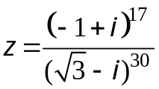.
- Solve the system of equation AX = b, where
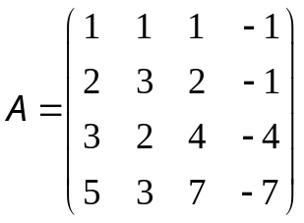, 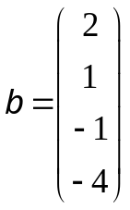,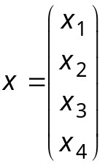

- Let 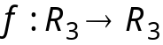 be a linear transformation.
Assume that
  - Find 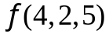.
  - Find the basis and dimension of Kerf.

- Let 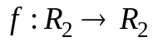 be a linear transformation, whose the matrix with respect to the basis 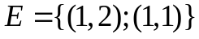 is 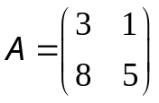
a. Find all eigenvalues and eigenvectors of 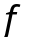.
b. Diagonalize (if possible).

5. Determine all value(s) m such that the matrix

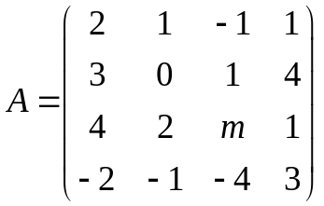 is invertible.
6. Find all value(s) m such that 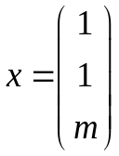 is an eigenvector of the matrix 

  

